Advanced Mixed-Effects Analyses

Paul D. Bliese
University of South Carolina

Presented at CARMA
June 9-11, 2016

Outline

I. Introduction and overview to Multilevel Models and R (PowerPoint)
Exercise 1: Importing Data from EXCEL and SPSS

II. Growth Modeling (PowerPoint)
Exercise 2: Growth Modeling Data Set Up
Exercise 3: Growth Modeling Example

III. Discontinuous Growth Models (PowerPoint)
Exercise 4: Data Set Up
Exercise 5: Create Time-Related Covariates
Exercise 6: Steps 1 to 4 in Analyzing and Interpreting Discontinuous Models
Exercise 7: Step 5 – Contrast Alternative Models
Exercise 8: Step 6 – Adding State-Level Predictors

IV. Multilevel Mediation (PowerPoint): No Exercise

V. Empirical Bayes Estimates (PowerPoint)
Exercise embedded in slide deck

VI. Generalized Linear Mixed Effects Models (GLMMs) and Dichotomous Outcomes
Exercises embedded in slide deck

VII. Three Level Models and Other Extensions in lme and lmer

Exercise 1: Importing Data from EXCEL and SPSS

Large data objects are typically created from external files using read.table of which there are several variants detailed in the help files. R can also import data from a number of other formats (SAS, SPSS, etc) using functions in the foreign library.
The option file="clipboard" with read.table makes it possible to copy large EXCEL files directly into R.
The use of the file.choose function with any of the data importing functions makes it possible to select files using the mouse and graphical user interface.

Detailed Example of Reading in EXCEL files directly from the Windows clipboard:
- Open the EXCEL file “cohesion.xls”
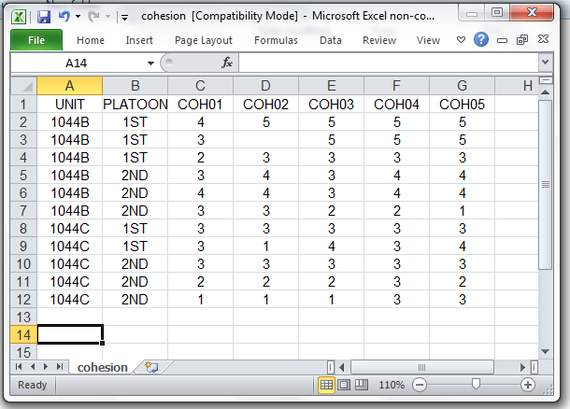

- Highlight the cells of the table and copy them to the Windows clipboard (Ctrl-C or right-click the mouse and use Copy)
- Create an R dataframe using the command:

> cohesion<-read.table(file="clipboard",sep="\t",header=T)
The sep option tells read.table tabs are being used to separate the fields. The header option indicates that the first row contains field names.

- Summarize the variables in the data frame using the summary command
> summary(cohesion)

Detailed Example of Reading in SPSS files
SPSS files are imported using the foreign library.

- Attach the foreign package
> library(foreign)
- See what functions are available in the package and get the details for read.spss
> help(package="foreign")
> help(read.spss)
- Create a data frame from the SPSS file “cohesion.sav” using numbers instead of the value labels and import the data directly into a data frame. Use the file.choose command to find the SPSS file using the mouse.

> cohesion2<-read.spss(file.choose(), use.value.labels=F, to.data.frame=T)

- Summarize the variables in the data frame using the summary command
> summary(cohesion2)

On your own:
- Convert the Klein2000.xls file into an R data.frame named kleinexcel by using the read.table command. Klein2000.xls is the simulated data set used in Klein, et al., (2000).
- Summarize and then delete the kleinexcel dataframe.
- Convert the klein2000.sav file into an R data.frame named klein2000 using the read.spss command. We will use this dataframe for a number of examples, so do not delete it.
- Regress Job Satisfaction (JOBSAT) on cohesion (COHES), workload (WLOAD) and the COHES*WLOAD interaction. You will use the lm (linear model) command that you first encountered in the sample session. Recall that a formula is specified as: DV~IV1+IV2 or DV~IV1*IV2. The first form regresses the DV on the main effects, and the second form regresses the DV on the main effects and the interaction. The specific commands are: tmod.1<-lm(JOBSAT~COHES+WLOAD,data=klein2000) and tmod.2<-lm(JOBSAT~COHES*WLOAD, data=klein2000). Summarize tmod.1 and tmod.2 and see the differences between models.
Exercise 2: Growth Modeling Data Set Up

Step-by-Step
Often, the first step in conducting growth modeling is to format the data so each repeated measure is on a separate row indexed by TIME. Reformatting is necessary because data is typically stored in a format where each row represents contains multiple observations from one individua. For instance, an individual might provide three measures of job satisfaction in a longitudinal study, and the data might be arranged such that column 1 is the subject number; column 2 is job satisfaction at time 1; column 3 is job satisfaction at time 2, and column 4 is job satisfaction at time 3, etc.
The chen2005 data frame in the multilevel library allows us to illustrate how data is often stored and how it must be reformatted prior to conducting growth modeling. Chen (2005) contains team leader ratings of newcomers at three time points. The newcomer ratings within a team are averaged so the values represent team-level constructs. Chen (2005) was interested in modeling team-level newcomer performance over time. In the chen2005 data frame, the repeated observations are indexed by T1, T2 and T3 in a single row.
> library(multilevel)
> data(chen2005)
> names(chen2005)
[1] "ID" "TMPRF" "TMEXP" "NCEMP" "NCPRF.T1" "NCPRF.T2" "NCPRF.T3"
> nrow(chen2005)
[1] 65
> help(chen2005)
These commands (a) bring the data frame from the multilevel library into our working environment, (b) list the column names of the dataframe, and (c) show that are 65 teams (one for each row). The help command provides additional detail about the data. If we examine the first 5 rows, we can see that each row contains complete data for each team. In team number 1, the newcomers performance was rated 2.72 at Time 1; 3.18 and Time 2, and 2.97 at Time 3.
> chen2005[1:5,]
ID TMPRF TMEXP NCEMP NCPRF.T1 NCPRF.T2 NCPRF.T3
1 1 3.45 3.96 4.00 2.72 3.18 2.97
2 2 3.45 3.60 4.58 3.60 3.42 3.75
3 3 4.45 3.94 3.92 3.74 3.53 3.68
4 4 3.82 3.97 2.67 3.11 3.49 3.47
5 5 4.55 4.21 4.42 3.40 3.71 3.90
From a growth modeling perspective, the problem with multivariate data frames like chen2005 is that they do not contain a variable that indexes time. That is, we know time is an attribute of this data because we have three different measures of performance (NCPRF.T1, NCPRF.T2 and NCPRF.T3); however, analytically we lack a single variable that explicitly indexes time. To create a variable that indexes time, we need to transform the data to univariate or a stacked format.
The make.univ function from the multilevel package provides a simple way to perform this transformation. Two arguments are required in the make.univ function. The first required argument required is the original data frame, and the second required argument is a data frame specifying the columns containing the repeated measures. The latter argument must be time-sorted. That is column 1 must be time 1, column 2 must be time 2, etc. For instance to convert chen2005 into univariate form we issue the following command:
> chen2005.univ<-make.univ(chen2005,chen2005[,5:7])
> chen2005.univ[1:9,]
ID TMPRF TMEXP NCEMP NCPRF.T1 NCPRF.T2 NCPRF.T3 TIME MULTDV
1 1 3.45 3.96 4.00 2.72 3.18 2.97 0 2.72
1.1 1 3.45 3.96 4.00 2.72 3.18 2.97 1 3.18
1.2 1 3.45 3.96 4.00 2.72 3.18 2.97 2 2.97
2 2 3.45 3.60 4.58 3.60 3.42 3.75 0 3.60
2.1 2 3.45 3.60 4.58 3.60 3.42 3.75 1 3.42
2.2 2 3.45 3.60 4.58 3.60 3.42 3.75 2 3.75
3 3 4.45 3.94 3.92 3.74 3.53 3.68 0 3.74
3.1 3 4.45 3.94 3.92 3.74 3.53 3.68 1 3.53
3.2 3 4.45 3.94 3.92 3.74 3.53 3.68 2 3.68

Note that each team now has three rows of data indexed by the variable “TIME”. Time ranges from 0 to 2. To facilitate model interpretation, the first time is coded as 0. This coding allows the model intercept to index team performance at the first point of the data collection. Second, notice that the make.univ function has created a variable called “MULTDV”. This variable represents the multivariate dependent variable (the name can be changed by using the outname option in make.univ). The variable “TIME” and the variable “MULTDV” are two of the primary variables used in growth modeling. Finally, notice that ID, TMPRF, TMEXP, and NCEMP and the values for the three performance variables were repeated three times for each team. By repeating the variables, the make.univ function has essentially created a data frame with level-2 variables in the proper format. For instance, TMEXP (Team Expectations) can now be used as a level-2 predictor in subsequent modeling.

In practice, it is often helpful to rename the default variable “MULTDV” into something more meaningful and it is a best practice to specify the exact column names of the repeated measures rather than rely on column numbers to avoid errors. Below is an example where MULTDV is renamed “PERF” and where column names are specified.

> chen2005.univ<-make.univ(chen2005, chen2005[,c("NCPRF.T1",
"NCPRF.T2","NCPRF.T3")], outname="PERF")
> chen2005.univ[1:9,]
ID TMPRF TMEXP NCEMP NCPRF.T1 NCPRF.T2 NCPRF.T3 TIME PERF
1 1 3.45 3.96 4.00 2.72 3.18 2.97 0 2.72
1.1 1 3.45 3.96 4.00 2.72 3.18 2.97 1 3.18
1.2 1 3.45 3.96 4.00 2.72 3.18 2.97 2 2.97
2 2 3.45 3.60 4.58 3.60 3.42 3.75 0 3.60
2.1 2 3.45 3.60 4.58 3.60 3.42 3.75 1 3.42
2.2 2 3.45 3.60 4.58 3.60 3.42 3.75 2 3.75
3 3 4.45 3.94 3.92 3.74 3.53 3.68 0 3.74
3.1 3 4.45 3.94 3.92 3.74 3.53 3.68 1 3.53
3.2 3 4.45 3.94 3.92 3.74 3.53 3.68 2 3.68

On-Your-Own

Read in the SPSS growth file and convert it to a univariate data frame ready for growth modeling. The data file contains a Subject number, respondent age, respondent marital status, respondent gender and three measures of commitment over time.

Exercise 3: Growth Modeling Example

Step-by-Step
This exercise examines changes in Job Satisfaction using the univbct dataframe from the multilevel package. The data is already arranged in multivariate form; however, we will create a smaller dataframe called UNIV.JSAT for the exercise.

>data(univbct)
>names(univbct)
[1] "BTN" "COMPANY" "MARITAL" "GENDER" "HOWLONG"
[6] "RANK" "EDUCATE" "AGE" "JOBSAT1" "COMMIT1"
[11] "READY1" "JOBSAT2" "COMMIT2" "READY2" "JOBSAT3"
[16] "COMMIT3" "READY3" "TIME" "JSAT" "COMMIT"
[21] "READY" "SUBNUM"
>UNIV.JSAT<-univbct[,c(22,1:9,12,15,18,19)]
>names(UNIV.JSAT)
[1] "SUBNUM" "BTN" "COMPANY" "MARITAL" "GENDER"
[6] "HOWLONG" "RANK" "EDUCATE" "AGE" "JOBSAT1"
[11] "JOBSAT2" "JOBSAT3" "TIME" "JSAT"

Begin by visually examining whether we see patterns between time and job satisfaction. The commands below use the lattice package to produce a plot of the first 30 individuals:

>library(lattice)
> xyplot(JSAT~TIME|as.factor(SUBNUM),data=UNIV.JSAT[1:90,],
type=c("p","r","g"),col="blue",col.line="black",
xlab="Time",ylab="Job Satisfaction")
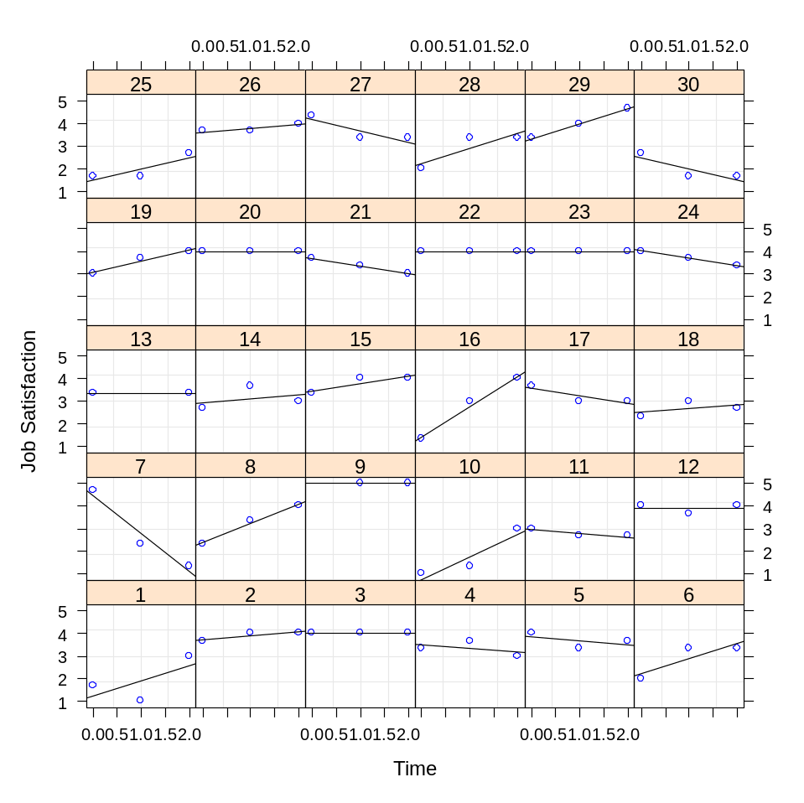
From this plot, it appears as though there is considerable variability both in overall levels of job satisfaction and in how job satisfaction changes over time. The goal in growth modeling is to determine whether or not we can find consistent patterns in the relationship between time and job satisfaction. Thus, we are now ready to illustrate growth modeling in a step-by-step approach. In this illustration, we follow the model comparison approach outlined by Bliese and Ployhart (2002) and in also discussed in Ployhart, Holtz and Bliese (2002).
As overview of the steps, the basic procedure is to start by examining the nature of the outcome. Much as we did in multilevel modeling, we are interested in estimating the ICC and determining whether the outcome (job satisfaction) randomly varies among individuals. Second, we are interested in examining the form of the relationship between time and the outcome. In essence, we want to know whether the outcome generally increases, decreases, or shows some other type of relationship with time. The plot of the first 30 individuals shows no clear pattern in how job satisfaction is changing over time, but the analysis might identify an overall trend among the 495 respondents. Third, we attempt to determine whether the relationship between time and the outcome is constant among individuals or whether it varies individual-by-individual. Fourth, we model in more complicated error structures such as autocorrelation, and finally we add level-2 predictors of intercept and slope variances.

Step 1: Examine the DV
The first step in growth modeling is to examine the properties of the dependent variable. As in multilevel modeling, one begins by estimating a null model and calculating the ICC. The following examples use the optim function to derive the restricted maximum likelihood estimates of the model parameters. The default nlmimb function tends to be less robust in more complex models and thereby produce more convergence errors.
> null.model<-lme(JSAT~1,random=~1|SUBNUM,data=UNIV.JSAT,
na.action=na.omit, control=list(opt="optim"))
> VarCorr(null.model)
SUBNUM = pdLogChol(1)
Variance StdDev
(Intercept) 0.4337729 0.6586144
Residual 0.4319055 0.6571952
> 0.4337729/(0.4337729+0.4319055)
[1] 0.5010786
In our example using the UNIV.GROW data frame, the ICC associated with job satisfaction is .50. This indicates that 50% of the variance in any individual report of job satisfaction can be explained by the properties of the individual who provided the rating. Another way to think about this is to note that individuals tend to remain fairly constant in ratings over time, and that there are differences among individuals. This observation is reflected in the graph of the first 30 respondents.

Step 2: Model Time
Step two involves modeling the fixed relationship between time and the dependent variable. In almost all cases, one will begin by modeling a linear relationship and progressively add more complicated structures such as quadratic, cubic, etc. To test whether there is a linear relationship between time and job satisfaction, we regress job satisfaction on time in a model with a random intercept.
> model.2<-lme(JSAT~TIME,random=~1|SUBNUM,data=UNIV.JSAT,
na.action=na.omit,control=list(opt="optim"))
> summary(model.2)$tTable
Value Std.Error DF t-value p-value
(Intercept) 3.21886617 0.04075699 903 78.977040 0.00000000
TIME 0.05176461 0.02168024 903 2.387640 0.01716169
An examination of the fixed effects indicates that there is a significant linear relationship between time and job satisfaction such that job satisfaction increases by .05 each time period. Note that since the first time period was coded as 0, the intercept value in this model represents the average level of job satisfaction at the first time period. Specifically, at the first time period the average job satisfaction was 3.22.
More complicated time functions can be included in one of two ways – either through raising the time variable to various powers, or by converting time into power polynomials. Below both techniques are illustrated.
> model.2b<-lme(JSAT~TIME+I(TIME^2),random=~1|SUBNUM,
data=UNIV.JSAT,na.action=na.omit,control=list(opt="optim"))
> summary(model.2b)$tTable
Value Std.Error DF t-value p-value
(Intercept) 3.23308157 0.04262697 902 75.8459120 0.0000000
TIME -0.03373846 0.07816572 902 -0.4316273 0.6661154
I(TIME^2) 0.04276425 0.03756137 902 1.1385167 0.2552071

> model.2c<-lme(JSAT~poly(TIME,2),random=~1|SUBNUM,
data=UNIV.JSAT,na.action=na.omit,control=list(opt="optim"))
> summary(model.2c)$tTable
Value Std.Error DF t-value p-value
(Intercept) 3.2704416 0.0346156 902 94.478836 0.00000000
poly(TIME, 2)1 1.5778835 0.6613714 902 2.385775 0.01724863
poly(TIME, 2)2 0.7530736 0.6614515 902 1.138517 0.25520707
Both models clearly show that there is no significant quadratic trend. Note that a key advantage of the power polynomials is that the linear and quadratic effects are orthogonal. Thus, in the second model the linear effect of time is still significant even with the quadratic effect in the model. In either case, however, we conclude that time only has a linear relationship with job satisfaction.

Step 3: Model Slope Variability
A potential limitation with model 2 is that it assumes that the relationship between time and job satisfaction is constant for all individuals. Specifically, it assumes that each individual increases job satisfaction by .05 points at each time period. An alternative model that needs to be tested is one that allows slopes to randomly vary. Given the degree of variability in the graph of the first 30 respondents, a random slope model seems quite plausible with the current data. A random slope model is tested by adding the linear effect for time as a random effect. In the running example, we can simply update model.2 by adding a different random effect component and contrast model 2 and model 3.
> model.3<-update(model.2,random=~TIME|SUBNUM)
> anova(model.2,model.3)
Model df AIC BIC logLik Test L.Ratio p-value
model.2 1 4 3461.234 3482.194 -1726.617
model.3 2 6 3434.132 3465.571 -1711.066 1 vs 2 31.10262 <.0001
The results clearly indicate that a model that allows the slope between time and job satisfaction to randomly vary fits the data better than a model that fixes the slope to a constant value for all individuals.
In cases where higher-level trends were also significant, one would also be interested in determining whether allowing the slopes of the higher-level variables to randomly vary also improved model fit. For instance, one might find that a quadratic relationship varied in strength among individuals.

Step 4: Modeling Error Structures
The fourth step in developing the level-1 model involves assessing the error structure of the model. It is important to carefully scrutinize the level-1 error structure because significance tests may be dramatically affected if error structures are not properly specified. The goal of step 4 is to determine whether one’s model fit improves by incorporating (a) an autoregressive structure with serial correlations and (b) heterogeneity in the error structures.
Tests for autoregressive structure (autocorrelation) are conducted by including the correlation option in lme. For instance, we can update model.3 and include lag 1 autocorrelation as follows:
> model.4a<-update(model.3,correlation=corAR1())
> anova(model.3,model.4a)
Model df AIC BIC logLik Test L.Ratio p-value
model.3 1 6 3434.132 3465.571 -1711.066
model.4a 2 7 3429.771 3466.451 -1707.886 1 vs 2 6.360465 0.0117
A model that allows for autocorrelation fits the data better than does a model that assumes no autocorrelation. A summary of model 4a reveals that the autocorrelation estimate is .367 (see the Phi coefficient).
> summary(model.4a)
Linear mixed-effects model fit by REML
Data: UNIV.JSAT
AIC BIC logLik
3429.771 3466.451 -1707.886
.....
Correlation Structure: AR(1)
Formula: ~1 | SUBNUM
Parameter estimate(s):
Phi
0.3676831
Finally, we can examine the degree to which the variance of the responses changes over time. A simple preliminary test of variance homogeneity can be conducted by examining the variance of job satisfaction at each time point using the tapply command.
> tapply(UNIV.JSAT$JSAT,UNIV.JSAT$TIME,var,na.rm=T)
0 1 2
0.9681912 0.8831397 0.7313358
The analysis suggests the variance of job satisfaction is decreasing over time. To model decreasing variance one can use the varExp option. In cases where variance increases can use the varFixed option (see Pinheiro & Bates, 2000 for details).
> model.4b<-update(model.4a,weights=varExp(form=~TIME))
> anova(model.4a,model.4b)
Model df AIC BIC logLik Test L.Ratio p-value
model.4a 1 7 3429.771 3466.451 -1707.886
model.4b 2 8 3428.390 3470.309 -1706.195 1 vs 2 3.381686 0.0659
The model that includes both autocorrelation and allows for decreases in variance fits the data marginally better (using a liberal p-value) than does the model that only includes autocorrelation. In subsequent analyses, however, model.4b ran into convergence problems. Consequently, we elect to use model.4a as our final level-1 model.
With the completion of step 4, we have exhaustively examined the form of the level-1 relationship between time and job satisfaction. This analysis has revealed that (a) individuals randomly vary in terms of their mean levels of job satisfaction, (b) there is a linear, but not quadratic, relationship between time and job satisfaction, (c) the strength of the linear relationships randomly varies among individuals, and (d) there is a fair amount of autocorrelation in the data. At this point, we are ready to add level-2 variables to try and explain the random variation in intercepts (i.e., mean job satisfaction) and in the time-job satisfaction slope.

Step 5: Predicting Intercept Variation
Step 5 in growth modeling is to examine factors that can potentially explain intercept variation. Specifically, in our case we are interested in examining factors that explain why some individuals have high job satisfaction while other individuals have low job satisfaction. In this example, we explore the idea that age is related to intercept variation.
To model this relationship, the individual-level characteristic, age, is used as a predictor of the job satisfaction intercept. The model that we will test is represented below using the Bryk and Raudenbush (1992) notation.
Y_{ij} = π_{0j} + π_{1j}(Time_{ij}) + r_{ij}
π_{0j} = β₀₀ + β₀₁(Age_{j}) + u_{0j}
π_{1j} = β₁₀ + u_{1j}
This equation states that respondent j’s initial job satisfaction (π_{0j}) can be modeled as a function of two things. One is the mean level of job satisfaction (β₀₀) for all respondents. The second is a coefficient associated with the individual’s age (β₀₁). Note that the error term for the intercept (u_{0j}) now represents the difference between an individuals’ intercept and the overall intercept after accounting for age. In lme the model is specified as:

> model.5<-lme(JSAT~TIME+AGE,random=~TIME|SUBNUM,
correlation=corAR1(),na.action=na.omit,data=UNIV.JSAT,
control=list(opt="optim"))

> round(summary(model.5)$tTable,dig=3)
Value Std.Error DF t-value p-value
(Intercept) 2.347 0.146 897 16.086 0.000
TIME 0.053 0.024 897 2.205 0.028
AGE 0.034 0.005 486 6.241 0.000
Model 5 differs only from Model 4a in that Model 5 includes a new fixed effect, AGE. Notice that age is positively related to initial levels of job satisfaction. Also notice that there are fewer degrees of freedom for age than for time since age is an individual (level-2) attribute.

Step 6: Predicting Slope Variation
The final aspect of growth modeling involves attempting to determine attributes of individual respondents that are related to slope variability. In this section, we attempt to determine whether respondent age can explain some of the variation in the time-job satisfaction slope. The model that we test is presented below:
Y_{ij} = π_{0j} + π_{1j}(Time_{ij}) + r_{ij}
π_{0j} = β₀₀ + β₀₁(Age_{j}) + u_{0j}
π_{1j} = β₁₀ + β₁₁(Age_{j}) + u_{1j}
This model is similar to the model specified in step 5 except that we now test the assumption that the slope between time and job satisfaction for an individual (π_{1j}) is a function of an overall slope (β₁₀), individual age (β₁₁), and an error term (u_{1j}). In lme, the model is specified as:
> model.6<-lme(JSAT~TIME*AGE,random=~TIME|SUBNUM,
correlation=corAR1(),na.action=na.omit,data=UNIV.JSAT,
control=list(opt="optim"))
Note that the only difference between model 5 and model 6 is that we include an interaction term for time and age. A summary of model 6 reveals that there is a significant interaction between time and age.
> round(summary(model.6)$tTable,dig=3)
Value Std.Error DF t-value p-value
(Intercept) 2.098 0.186 896 11.264 0.000
TIME 0.271 0.104 896 2.608 0.009
AGE 0.043 0.007 486 6.180 0.000
TIME:AGE -0.008 0.004 896 -2.153 0.032
The predict function can be used in conjunction with the interaction.plot function to plot out the form of the interaction. First, create a small dataframe containing high and low values for age (21 and 31) and the two time points of time 0 and time 2. Second, add a variable to the small dataframe with the predicted values. Finally, use interaction.plot to graph the interaction.

> TDAT<-data.frame(TIME=c(0,0,2,2),AGE=c(21,31,21,31))
> TDAT$JOBSAT<-predict(model.6,TDAT,level=0)
> TDAT
TIME AGE JOBSAT
1 0 21 3.010647
2 0 31 3.444704
3 2 21 3.198360
4 2 31 3.463884
> interaction.plot(TDAT$TIME,TDAT$AGE,TDAT$JOBSAT,ylim=c(2,4))
> #Or use 'with' to avoid typing TDAT$ 3 times
> with(TDAT,interaction.plot(TIME,AGE,JOBSAT,ylim=c(2,4)))
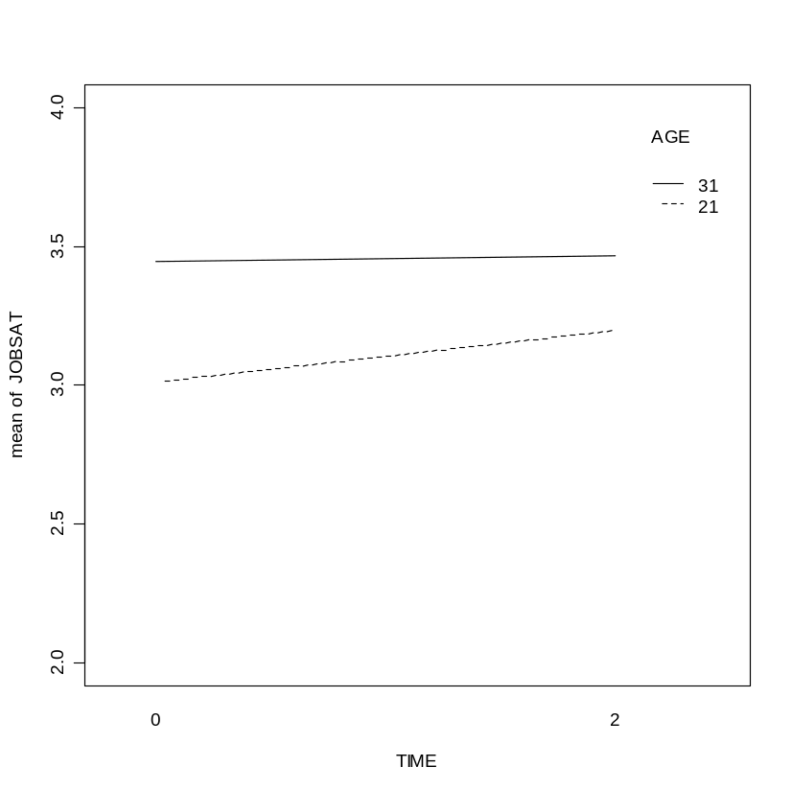

On-Your-Own

Use the univariate form of the growth data you created in exercise 10 to perform a growth-modeling analysis of commitment.
- Start with a plot of time and commitment for the first 30 respondents (use rows 1:90 as in the example graph at the beginning of the exercise)
- Follow each step of the process as outlined above
- See if the commitment intercept (average levels of commitment) and the time-commitment slope vary as a function of the level-2 variable gender.
Hints:
- To avoid convergence problems, use the optim function (control=list(opt="optim"))
- Both the linear and quadratic effects are significant, so you need to test whether the linear and quadratic effects also randomly vary across individuals. To do this, contrast three models, (a) random intercept, (b) random linear slope, (c) random linear and quadratic slope. [random=~poly(TIME,1)|SUBNUM] vs [random=~poly(TIME,2)|SUBNUM]
- The TIME*GENDER interaction is significant. A quick way to look at the plot is to use the interaction.plot function along with predict.

> TDAT<-data.frame(TIME=c(0,0,2,2),GENDER=c(1,2,1,2))
> TDAT$COMMIT<-predict(tmod,TDAT,level=0)
> with(TDAT,interaction.plot(TIME,GENDER,COMMIT))
Exercise 4: Data Set Up

Step-by-Step
Often, the first step in conducting growth modeling is to format the data so that each repeated measure is on a separate row indexed by TIME. Reformatting is necessary because data is typically stored so that each row contains multiple observations from one individual. For instance, an individual might provide three measures of job satisfaction in a longitudinal study, and the data might be arranged such that column 1 is the subject number; column 2 is job satisfaction at time 1; column 3 is job satisfaction at time 2, and column 4 is job satisfaction at time 3, etc.
The EXCEL gdp data (state gdp 1997 to 2011.xls) illustrates a typical data structure that must be reformatted prior to conducting a growth model analysis. The sleep data contain an ID (state), one state-level variable (pinc08 or State-level Personal Income in 2008) in addition to 15 years of gdp. The format is presented below.

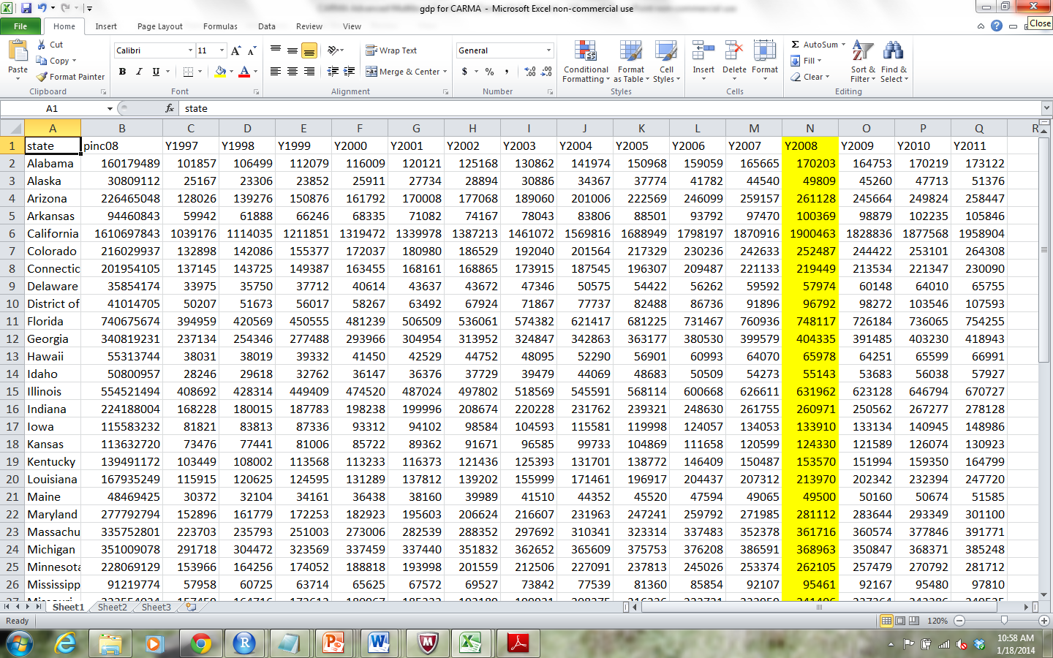
We can create a dataframe in R by (a) copying the cell in EXCEL (Ctrl-C) and typing the following commands (According to the Web, Mac OS X users can use pipe("pbpaste") and pipe("pbcopy", "w") to read from and write to that system's clipboard):
> gdpdata<-read.delim(file="clipboard")
> names(gdpdata)
> names(gdpdata)
[1] "state" "pinc08" "Y1997" "Y1998" "Y1999" "Y2000"
[7] "Y2001" "Y2002" "Y2003" "Y2004" "Y2005" "Y2006"
[13] "Y2007" "Y2008" "Y2009" "Y2010" "Y2011"

> nrow(gdpdata)
[1] 51
These commands (a) create a dataframe named gdp, (b) list the column names of the dataframe, and (c) show that there are 51 States (one for each row: District of Columbia is included). The format of the data in the gdp dataframe mirror that of the EXCEL file. Below we look at the first five rows and columns 1 to3 and 8 to 10:
> gdpdata[1:5,c(1:3,8:10)]
state pinc08 Y1997 Y2002 Y2003 Y2004
1 Alabama 160179489 101857 125168 130862 141974
2 Alaska 30809112 25167 28894 30886 34367
3 Arizona 226465048 128026 177068 189060 201006
4 Arkansas 94460843 59942 74167 78043 83806
5 California 1610697843 1039176 1387213 1461072 1569816

From a growth modeling perspective, the problem with multivariate dataframes like gdpdata is that they do not contain a variable that indexes time. To create a variable that indexes time, we need to transform the data to univariate or stacked format.
The make.univ function from the multilevel package provides a simple way to perform this transformation. Two arguments are required in the make.univ function. The first required argument required is the original dataframe, and the second required argument is the subset of the dataframe specifying the columns containing the repeated measures. The latter argument must be time-sorted. That is column 1 must be time 1, column 2 must be time 2, etc. For instance to convert gdpdata into univariate form we issue the following command using the outname option to create a variable named “gdp”:
> gdpdata.univ<-make.univ(gdpdata,gdpdata[,3:17],
outname="gdp")

> gdpdata.univ[1:15,c(1:5,18:19)]
state pinc08 Y1997 Y1998 Y1999 TIME gdp
1 Alabama 160179489 101857 106499 112079 0 101857
1.1 Alabama 160179489 101857 106499 112079 1 106499
1.2 Alabama 160179489 101857 106499 112079 2 112079
1.3 Alabama 160179489 101857 106499 112079 3 116009
1.4 Alabama 160179489 101857 106499 112079 4 120121
1.5 Alabama 160179489 101857 106499 112079 5 125168
1.6 Alabama 160179489 101857 106499 112079 6 130862
1.7 Alabama 160179489 101857 106499 112079 7 141974
1.8 Alabama 160179489 101857 106499 112079 8 150968
1.9 Alabama 160179489 101857 106499 112079 9 159059
1.10 Alabama 160179489 101857 106499 112079 10 165665
1.11 Alabama 160179489 101857 106499 112079 11 170203
1.12 Alabama 160179489 101857 106499 112079 12 164753
1.13 Alabama 160179489 101857 106499 112079 13 170219
1.14 Alabama 160179489 101857 106499 112079 14 173122

Note that each State now has 15 rows of data indexed by the variable “TIME”. Time ranges from 0 to 14. To facilitate model interpretation, the first time is coded as 0. This coding allows the model intercept to index gdp at the first point of the data collection (1997). The variable “TIME” and the variable “gdp” are two of the primary variables used in growth modeling. Finally, notice that state, pinc08 (and all other variables in the original file) are repeated 15 times for each State. By repeating the variables, the make.univ function has essentially created a dataframe with level-2 variables in the proper format. For instance, pinc08 can now be used as a level-2 predictor in subsequent modeling.

On-Your-Own

Read in the EXCEL sleep actigraph data (sleep actigraph 26 day.xls) and convert it to a univariate dataframe ready for growth modeling. Call the original dataframe “sleep” and the univariate dataframe “sleep.univ”.
Exercise 5: Create Time-Related Covariates

Step-by-Step
In our illustrative example, we expect to capture State-level discontinuity in GDP change associated with the “great recession” of 2008. We specifically make the following predictions regarding GDP change:
1. GDP will increase over the 15 year period between 1997 and 2011.
2. The great recession as indexed by the year 2008 will produce a significant discontinuity in GDP. The specific form of the discontinuity is a drop in GDP.
3. The rate of GDP growth post 2008 is expected to differ from the rate of GDP growth prior to 2008. Specifically, post-recession growth will be slower than pre-recession growth.
To model these specific predictions, we need three time-based covariates: one covariate to capture the pre-recession slope (TIME); one covariate to capture the discontinuity in 2008 (TRANS), and one covariate to capture the post-recession growth rate.
The TIME covariate was created when we used make.univ to convert the data to long format and indexes the Years from 1997 to 2011 as 0:14. The time-based covariate associated with the transition (TRANS) is a dummy coded variable where 0 represents the years 1995 to 2007 and 1 represents the years 2008 to 2011. In our coding, the years 1995 to 2007 are represented by 0:10 in the TIME variable while the years 2008 to 2011 are represented by 11:14 in the TIME variable.
To create the time-based transition covariate in R, we create a new variable (TRANS) in the grpdata.univ dataframe. The TRANS variable takes on the value of 0 when TIME is 10 or less and takes on the value of 1 when TIME is 11 or greater. The ifelse command in R provides an efficient way to create the new variable.

> gdpdata.univ$TRANS<-ifelse(gdpdata.univ$TIME>10,1,0)

The third time-based covariate used to capture the post-transition recovery slope (RECOV) also represents a discontinuously coded variable much like the TRANS variable. Unlike the TRANS variable which only takes on 2 values in this example (0,1), the RECOV variable takes on multiple values to capture the recovery slope. In this specific example, the RECOV variable takes on a value of 0 for the years 1995 to 2007 (as did the TRANS variable); however, at the transition point (the year 2008 coded as 11 with the TIME variable), TRANS begins a linear index of time starting with 0 and followed by 1, 2, and 3. Creating this variable can be accomplished using two commands in R. The first command subtracts 11 from TIME so that RECOV is 0 at TIME 11 (2008), 1 at Time 12 (2009), 2 at time 13 (2010), and 3 at time 14 (2011). The second command coverts all negative values of RECOV to zero.

> gdpdata.univ$RECOV<-gdpdata.univ$TIME-11
> gdpdata.univ$RECOV[gdpdata.univ$RECOV<0]<-0

The final data structure with the three time-based covariates is provided below for the first State (Alabama) in the dataframe.

> gdpdata.univ[1:15,c("state","TIME","TRANS","RECOV")]
state TIME TRANS RECOV
1 Alabama 0 0 0
1.1 Alabama 1 0 0
1.2 Alabama 2 0 0
1.3 Alabama 3 0 0
1.4 Alabama 4 0 0
1.5 Alabama 5 0 0
1.6 Alabama 6 0 0
1.7 Alabama 7 0 0
1.8 Alabama 8 0 0
1.9 Alabama 9 0 0
1.10 Alabama 10 0 0
1.11 Alabama 11 1 0
1.12 Alabama 12 1 1
1.13 Alabama 13 1 2
1.14 Alabama 14 1 3

On-Your-Own

Use the dataframe “sleep.univ” created in the last exercise to create two new variables indexing the transition (TRANS) and the recovery slope (RECOV). In this example, participants transitioned on Day 17 from sleeping in a barracks environment to sleeping in tents in a field exercise. We are interested in understanding how the number of minutes of sleep was impacted by the transition and also understanding the nature of change post-transition.

Exercise 6: Steps 1 to 4 in Analyzing and Interpreting Discontinuous Models

Step-by-Step
Step 1: Estimate the ICC
The first step in analyzing discontinuous growth data is to estimate the ICC from the null model. In the nlme package, the lme (linear mixed-effects) function is used to estimate the mixed-effects model and the corresponding ICC(1) value. The use of the term, control=list(opt="optim"), is optional and changes the optimization program from the default nlimb optimizer to the optim optimizer. The optim optimizer is the standard optimization procedure in R. In its default setting, it uses the popular Nelder-Mead method (Nelder & Mead, 1965) and was initially used in the Pinheiro and Bates (2000) publication of the nlme library. More recent versions of nlme use another optimizer – the nlimb optimizer based on the port library by Gay (1990). Typically both optimization procedures converge and give comparable results. Occasionally, however, one optimizer does not converge and then the results of the other optimizer may be useful. In our experience, the optim optimizer tends to be somewhat more likely to converge in complex models. Therefore, given the complexity of the models illustrated we use optim.

> library(nlme)
> mod.null<-lme(gdp1k~1,random=~1|state,gdpdata.univ,
+ control=list(opt="optim"))
> VarCorr(mod.null)
Area = pdLogChol(1)
Variance StdDev
(Intercept) 76969.013 277.43290
Residual 5140.942 71.70036

> 76969.013/(76969.013+5140.942)
[1] 0.9373895

The ICC associated with GDP within States is large (.937) suggesting that approximately 94% of the variance in any one GDP measure can be explained by State membership. Practically speaking, this indicates that States differ substantially from each other in terms of GDP and that over time GDP within a State tends to be fairly stable. Note that it is common to encounter high ICC values in repeated measures data (>.50); however, the large ICC value observed here is potentially problematic because it indicates that the vast majority of the variance resides between groups (high consistency in responses within States) and therefore it may be difficult to model change. In the current example, we will see that the high ICC contributes to results that are significant but not particularly dramatic. Despite these caveats, we continue with the example because our main goal is to detail the analytic processes and steps for conducting the analyses.

Step 2: Model Time-Related Parameters
In typical growth models, the step following ICC estimation focuses on modeling the nature of change over time (e.g., Bliese & Ployhart, 2002). Discontinuous growth models mirror this step with the only variation being that we recommend (a) including the time covariates as a block of fixed-effects, and (b) integrating the random effects analyses of parameter variability prior to interpreting the fixed-effects. We begin by estimating the three fixed-effects associated with time in a model with a random intercept for State. This model allows States to vary in terms of overall levels of GDP, but fixes parameter estimates across States for the pre-discontinuity slope, the transition, and the recovery slope.

> mod2<-lme(gdp1k~TIME+TRANS+RECOV,random=~1|state,
gdpdata.univ,control=list(opt="optim"))
> summary(mod2)$tTable
Value Std.Error DF t-value p-value
(Intercept) 158.793971 39.1391429 711 4.0571653 5.517309e-05
TIME 10.867129 0.7594202 711 14.3097710 5.292652e-41
TRANS -5.498661 8.4223775 711 -0.6528633 5.140555e-01
RECOV -5.091427 3.6420514 711 -1.3979559 1.625623e-01

In this model, TIME is the only significant predictor. The model indicates that in 1997, the average level of GDP across the 51 States was 158793.971 (158.793971*1000) and that GDP increased by 10867.129 each year. The model indicates that GDP dropped by 5498.661 in 2008; however, the estimate of the standard error is large and indicates that the drop does not significantly differ from chance levels. Finally, the negative parameter for the recover slope (RECOV) of -5091.427 indicates the recovery slope is weaker than the slope associated with the period before 2008.
One of the points that we return to on several occasions centers on the importance of interpreting TRANS and RECOV relative to the TIME slope. For instance, while the parameter estimate associated with RECOV is negative, the recovery slope is still positive in absolute terms estimated as a 5775.702 increase per year post 2008 (10867.129 - 5091.427). Likewise, later we will illustrate that the negative term associated with the transition actually represents a slight increase (in absolute terms) because the discontinuity term at 2008 is indexed to the increase that would have been expected based on the TIME slope.

Step 3: Model State Variability in Time-Related Parameters
One concern with interpreting the fixed-effects at this point is the strong likelihood that the model is miss-specified by assuming each state is similar on the time-related model parameters. If States significantly vary on the time-related terms, the resulting Standard Error estimates may be too large. Therefore, it is important to test whether the terms associated with time significantly differ across level-2 units.
In mixed-effects models, tests for differences in parameter slopes associated with level-2 units are conducted by modifying the model’s random effects and contrasting the fit between models using the Chi-square -2 log-likelihood test (Deviance). In the case of discontinuous growth models, we recommend that model contrasts be conducted on a step-by-step basis to specifically determine which (if any) terms differ across level-2 units.
In our example, we estimate three alternative models and sequentially compare the models. The first model alternative (mod3.a) includes a random effect for TIME, and allows the overall Time-related slope to vary among States; the second model (mod3.b) adds a random effect for Trans in addition to the term for TIME and allows States to vary in terms of the degree of change in GDP they experienced in 2008; the final model (mod3.c) adds Recov to the random terms and allows the post 2008 GDP slope to vary among States. The anova function in R compares the fit of each model in terms of the -2 log likelihood values. In the comparisons, we test the first alternative model to the baseline model containing only the random intercept.

> mod3.a<-update(mod2,random=~TIME|state)
> mod3.b<-update(mod3.a,random=~TIME+TRANS|state)
> mod3.c<-update(mod3.b,random=~TIME+TRANS+RECOV|state)
> anova(mod2,mod3.a,mod3.b,mod3.c)
Model df AIC BIC logLik Test L.Ratio p-value
mod2 1 6 8641.864 8669.671 -4314.932
mod3.a 2 8 6683.111 6720.189 -3333.556 1 vs 2 1962.7521 <.0001
mod3.b 3 11 6540.190 6591.171 -3259.095 2 vs 3 148.9212 <.0001
mod3.c 4 15 6379.728 6449.247 -3174.864 3 vs 4 168.4627 <.0001

Notice that the inclusion of each additional parameter resulted in a significant increase in fit as indexed by the -2 log likelihood values. Fundamentally, this suggests that States significantly vary in terms of (a) the change in GDP between 1997 and 2008, (b) the degree to which GDP changed in 2008, and (c) the degree to which GDP increased after 2008. Parenthetically, while there is no ambiguity about the significance of the -2log likelihood tests in this example, it is important to keep in mind that these tests are widely known to be conservative (Pinheiro & Bates, 2000), so a generally acceptable practice is to halve the p-values as though the tests were one-tailed (LaHuis & Ferguson, 2009).
A summary of the fixed effects in mod3.c provides two insights. First, the estimates of the random effects show why the inclusion of each additional random effect requires an increasingly larger number of degrees of freedom. The inclusion of one random slope to a model with only a random intercept only requires estimating two parameters: a variance for the slope and a covariance between the slope and intercept. In contrast, the inclusion of a third random slope with a random intercept and two random slopes in the model requires estimating four terms – one variance term for the slope (indexed as the Standard Deviation of 9.115747) and three correlation terms (-0.859 -0.916 0.813).

> summary(mod3.c)
> summary(mod3.c,Correlation=F)
Linear mixed-effects model fit by REML
Data: gdp.univ
AIC BIC logLik
6379.728 6449.247 -3174.864

Random effects:
Formula: ~TIME + Trans + Recov | Area
Structure: General positive-definite, Log-Cholesky parametrization
StdDev Corr
(Intercept) 186.731813 (Intr) TIME Trans
TIME 14.196193 0.961
TRANS 12.689639 -0.714 -0.635
RECOV 9.115747 -0.859 -0.916 0.813
Residual 9.790312

Fixed effects: gdp1k ~ TIME + Trans + Recov
Value Std.Error DF t-value p-value
(Intercept) 158.79397 26.159116 711 6.070311 0.0000
TIME 10.86713 1.992157 711 5.454955 0.0000
TRANS -5.49866 2.293233 711 -2.397776 0.0168
RECOV -5.09143 1.422083 711 -3.580261 0.0004

The second insight from the summary of mod3.c is that all three of the parameter estimates (TIME, TRANS and RECOV) are significant. Recall that in the model with only a random intercept, only TIME was significant. In examining the fixed-effects, it is clear that the significance is due to a reduction in the standard error estimates relative to the original model. That is, both the original model with the random intercept term and the final model with random terms for the intercept and each of the time-based slopes have similar parameter estimates, but the smaller standard errors in the more complex model result in significant t-values. Interestingly, the interpretation of both models would be similar: both models convey that there is a high degree of uncertainty regarding the estimates of GDP decline in 2008 and in the recovery slope. The original model conveys the uncertainty by showing that TRANS and RECOV have large standard errors and are therefore non-significant: the second model conveys the uncertainty by showing that States have significant random-effect variability in these parameters. The advantage to the latter approach, however, is that we can include State-level predictors that help explain variance in the random-effect variance estimates.

Step 4: Examining the Within-Group Correlation Structure
In the previous models, we included random intercepts for States and therefore accounted for non-independence of repeated measures due to State membership. In other words, we have acknowledged that GDP measures at any time point are partially a function of the States from which they are drawn. Models with random intercepts estimated up to this point assume that there is no discernible pattern to the residual errors. That is, the models assume independent errors in the covariance structure of the data. While the assumption of independent errors is tenable for observations clustered within groups, it is rarely supported when dealing with repeated measures over time. As Littell, Milliken, Stroup, and Wolfinger (1996) note, “measurements taken at adjacent times are typically more highly correlated than two measurements taken several time points apart” (p. 88). Therefore, prior to interpreting model effects it is important to assess the within-group correlation structure of the fit model.
In lme, the correlation option allows one to specify and test alternative within-group correlation structures. A common structure is corAR1() or first-order autoregressive, and this alternative is fit by updating mod3.c and contrasting the -2 log likelihood values between the two models.

> mod4<-update(mod3.c,correlation=corAR1(form=~TIME|state))
> anova(mod3.c,mod4)
Model df AIC BIC logLik Test L.Ratio p-value
mod3.c 1 15 6379.728 6449.247 -3174.864
mod4 2 16 6095.525 6169.679 -3031.762 1 vs 2 286.2027 <.0001

Notice that mod4 estimates one more parameter (the phi-coefficient associated with the first-order autoregressive process) and that the model with this parameter provides significantly better fit than a model without this parameter.
A summary of mod4 reveals that the estimate of the phi-coefficient is 0.86 (strong evidence of first-order autoregressive structure). The t-table from mod4 also shows that the inclusion of this term upwardly adjusts the parameter estimates relative to mod3.c and differentially effects the SE estimates (mod4 SEs are larger for the Intercept, TIME and Recov, but smaller for Trans). In the end, the substantive conclusions drawn from both mod3.c (without a term for first-order regressive structure) and mod4 are similar, but mod4 is an improvement because it formally acknowledges that there is a pattern to the within-group residuals.

> summary(mod4)$tTable
Value Std.Error DF t-value p-value
(Intercept) 159.988745 26.245435 711 6.095870 1.784567e-09
TIME 11.004137 2.028843 711 5.423848 8.001880e-08
Trans -5.808946 1.992174 711 -2.915882 3.658477e-03
Recov -5.602026 1.520101 711 -3.685299 2.458043e-04

On-Your-Own

Use the dataframe “sleep.univ” and the time-related parameters (TIME, TRANS, RECOV) created in the last exercises to:
- Estimate the ICC(1)
- Examine the fixed effects associated with TIME, TRANS, and RECOV
- Determine if the time-related covariates (TIME, TRANS and RECOV) significantly differ among individuals (SUBNUM)
- Determine with the level-1 residuals have evidence of significant autocorrelation.

Hints:
- To avoid convergence problems, use the optim function (control=list(opt="optim"))
- These data have missing values, so it will be important to use na.action=na.omit within lme.
- Your first model is: null.mod<-lme(sleep~1,random=~1|SUBNUM, data=sleep.univ,na.action=na.omit, control=list(opt="optim"))
Exercise 7: Step 5 – Contrast Alternative Models

Simplified Modeling: Discontinuity with Equal Slopes
The basic model containing three total time-based parameters (TIME, TRANS, RECOV) can be modified to specify simplified forms of a discontinuous growth model. One useful model omits the post-transition vector (RECOV), while leaving the vector indexing TIME and the dichotomous vector TRANS. This variant allows for a discontinuity but restricts the pre-transition and post-transition slopes to be equal. We recommend using this model when theory suggests that pre- and post-transition slopes will be equal. We provide the code, the corresponding t-Table, and the figure illustrating the form of the model.

> mod5.a<-lme(gdp1k~TIME+TRANS,
random=~TIME+TRANS|state, gdpdata.univ,
correlation=corAR1(form=~TIME|state),
control=list(opt="optim"))

> round(summary(mod5.a)$tTable,dig=4)
Value Std.Error DF t-value p-value
(Intercept) 162.9069 26.9315 712 6.0489 0.0000
TIME 9.8017 1.7721 712 5.5310 0.0000
TRANS -4.8805 1.9446 712 -2.5097 0.0123

The form of the interactions is illustrated in the figure below. Notice how the pre-discontinuity and post-discontinuity slopes mirror each other.
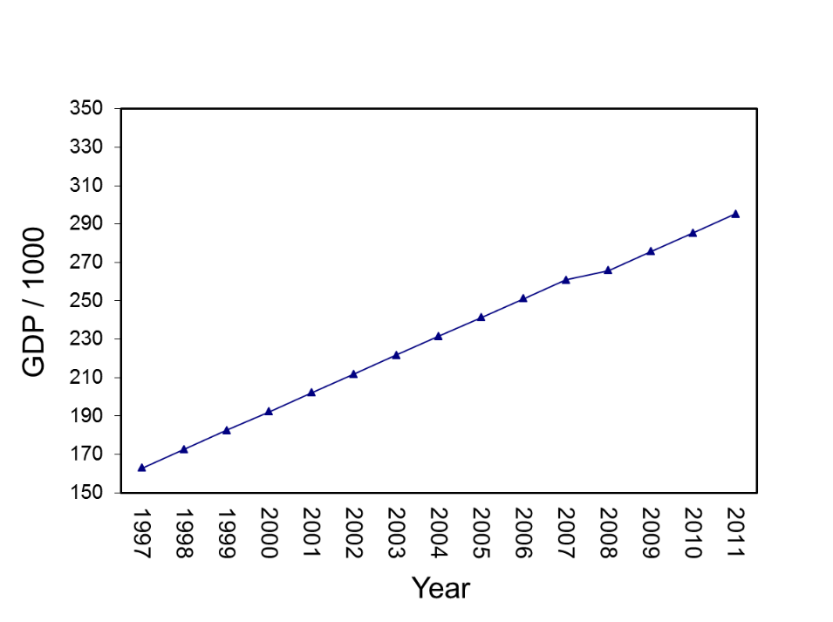

Discontinuity as a Slope Change

Another simplified model treats the discontinuity as a change in slope at a specific point. The model with two slopes uses the TIME and RECOV variables and omits TRANS. The code, corresponding t-Table, and the figure below illustrate this form of the model.

> mod5.b<-lme(gdp1k~TIME+RECOV,
random=~TIME+RECOV|state, gdpdata.univ,
correlation=corAR1(form=~TIME|state),
control=list(opt="optim"))

> round(summary(mod5.b)$tTable,dig=4)
Value Std.Error DF t-value p-value
(Intercept) 161.1470 26.4624 712 6.0897 0e+00
TIME 10.5338 1.9364 712 5.4399 0e+00
RECOV -5.3337 1.5104 712 -3.5314 4e-04

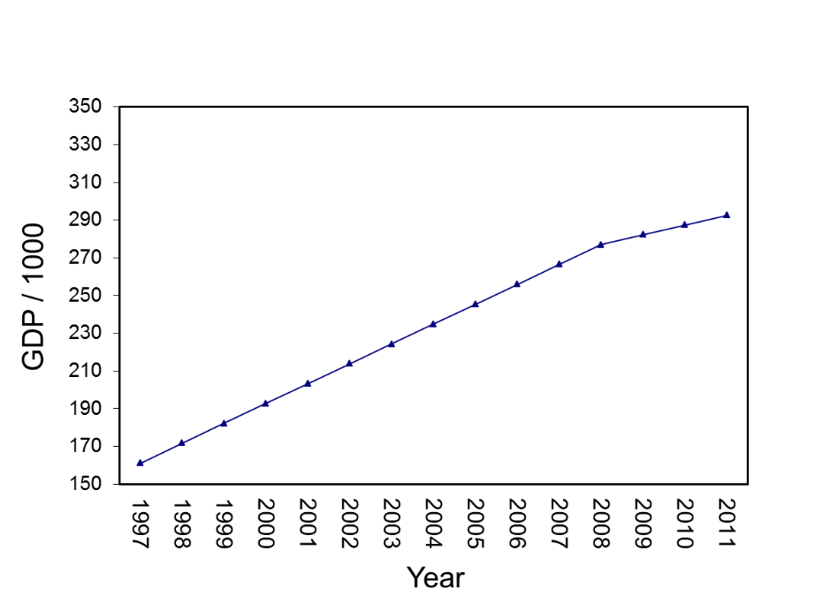

Notice the difference in the slope of the change prior to2008 and the slope of the change following 2008.

Contrasting Models.

The alternative forms of the models vary in terms of both fixed effects (different predictors) and random effects (different estimates of variances and covariances for slopes associated with the time-based parameters of TIME, TRANS, and RECOV). Under these situations, the use of -2log likelihood values to contrast models is limited because it is generally accepted that -2log likelihood tests are appropriate for contrasting models with different random effects when models are estimated using Restricted Maximum Likelihood (REML) while full Maximum Likelihood is necessary for contrasting models with different fixed effects (Pinheiro & Bates, 2000; Hox, 2002; Bryk & Raudenbush, 1992). In the absence of formal model contrasts, we suggest relying on Akaike's ‘An Information Criterion’ (AIC) and Schwarz's Bayesian criterion (BIC).

> data.frame(AIC(mod4), AIC(mod5.a), AIC(mod5.b))
AIC.mod4. AIC.mod5.a. AIC.mod5.b.
1 6095.525 6204.586 6133.767

> data.frame(BIC(mod4), BIC(mod5.a), BIC(mod5.b))
BIC.mod4. BIC.mod5.a. BIC.mod5.b.
1 6169.679 6255.581 6184.763

With both these criteria, smaller is better. The AIC values indicate that the full model is the best alternative. The BIC values (which penalize more heavily for additional parameters) favors the third alternative model where slopes were allowed to randomly vary pre and post 2008 without a discontinuity (TRANS) parameter. Ultimately, decisions about which model is superior need to be influenced by theory, but fit indices such as AIC and BIC are also useful in evaluating model fit.

On-Your-Own

Continue using the dataframe “sleep.univ” and build off the previous exercise by:
- Estimating a model with a discontinuity at Day 17, but equal slopes pre and post change
- Estimating a model where the slope changes at Day 17
- Contrast the fit of the three alternative models using AIC and BIC estimates.

Hints: Your model
- To avoid convergence problems, use the optim function (control=list(opt="optim"))
- These data have missing values, so it will be important to use na.action=na.omit within lme.
Exercise 8: Step 6 – Adding State-Level Predictors

Level-2 Predictors

The final step (and generally the most interesting) is to include level-2 predictors of the parameters previously identified to randomly vary among groups. In our example, we explore whether the wealth of a US state (as indexed by State-level Personal Income in 2008) explains differences in (a) overall levels of GDP , (b) GDP growth from 1997 to 2008, (c) the extend of the GDP drop in 2008, and (d) GDP growth following the 2008 decline.
A model determining whether State-Level Personal Income in 2008 (Pinc2008) is related to overall levels of GDP is estimated by including Pinc2008 as a level-2 main-effect predictor of the intercept. We begin, however, by re-scaling State-Level Personal Income in 2008 by dividing it by 100,000 to make the parameter estimates and standard errors large enough to be displayed as something other than zeros in the tables.

> gdpdata.univ$pinc08.100k<-gdpdata.univ$pinc08/100000

> mod6.a<-lme(gdp1k~TIME+TRANS+RECOV+pinc08.100k,
random=~TIME+TRANS+RECOV|state, gdpdata.univ,
correlation=corAR1(form=~TIME|state),
control=list(opt="optim"))

> round(summary(mod6.a)$tTable,dig=4)
Value Std.Error DF t-value p-value
(Intercept) -59.1073 11.2495 711 -5.2542 0.0000
TIME 10.9638 2.0116 711 5.4503 0.0000
TRANS -5.7022 1.8716 711 -3.0468 0.0024
RECOV -5.4556 1.5095 711 -3.6142 0.0003
pinc08.100k 0.0897 0.0009 49 99.1366 0.0000

Perhaps not surprisingly, personal wealth in a State in 2008 has a strong positive relationship with the average level of GDP in a State across the 15 years (notice the t-value of 99.14). Another way to understand the magnitude and form of this relationship would be to examine the estimates of the random effects using VarCorr on mod4 and contrast the mod4 variance estimates with those from mod6.a. As noted by Preacher, Zyphur, and Zhang (2010), a level-2 variable such as Pinc20081k which is constant within States can only explain intercept variance (e.g., average State levels of GDP). In mod4, the intercept variance (tau00) is 34,771.28; however, after including the level-2 predictor in mod6.a the intercept variance drops to 5,939.47. Other variance estimates also show some minor variability; however, the intercept variance estimate clearly shows that levels of personal wealth in 2008 in a State are strong predictors of average GDP in the State over the 15 year period.
The next step in estimating a discontinuous growth model is to determine whether the level-2 variable is related to (a) the initial slope, (b) the transition and (c) the recovery slope. We recommend that these cross-level interactions be examined as a simultaneous block. In practice, though, the simultaneous inclusion of three interaction terms may result in multicolinearity, so it is important to conduct follow-up analyses examining each cross-level interaction if the simultaneous examination of all three cross-level interactions returns non-significant results or if the models fail to converge. In this example, all three interactions are significant. Note that when an interaction is specified in R (e.g., TIME*pinc08.100k), the models assume that both main effects should be included so it is not necessary to specify main effects and interactions separately.

> mod6.b<-lme(gdp1k~TIME*pinc08.100k+
TRANS*pinc08.100k+RECOV*pinc08.100k,
random=~TIME+TRANS+RECOV|state, gdpdata.univ,
correlation=corAR1(form=~TIME|state),
control=list(opt="optim"))

> round(summary(mod6.b)$tTable,dig=4)
Value Std.Error DF t-value p-value
(Intercept) 4.0122 4.3978 708 0.9123 0.3619
TIME -0.8922 0.5077 708 -1.7574 0.0793
pinc08.100k 0.0638 0.0012 49 54.8118 0.0000
TRANS 1.5105 2.1745 708 0.6946 0.4875
RECOV 1.8000 1.1817 708 1.5232 0.1281
TIME:pinc08.100k 0.0048 0.0001 708 36.0762 0.0000
pinc08.100k:TRANS -0.0029 0.0006 708 -5.0823 0.0000
pinc08.100k:RECOV -0.0029 0.0003 708 -9.3703 0.0000

Judging from the t-values, a State’s Personal Income appears to have a relatively large impact on the GDP slope prior to 2008 and relatively weak (but significant) effects on the Transition and Recovery slopes.

Normally, to plot the form of the interaction, one would choose high and low values by selecting one SD above and one SD below the mean; however, in this example Personal Income is skewed by several States with high values, so one SD below the mean returns a negative value. Consequently, we illustrate the form using the median, a value at the 33rd Percentile and a value at the 66th Percentile.

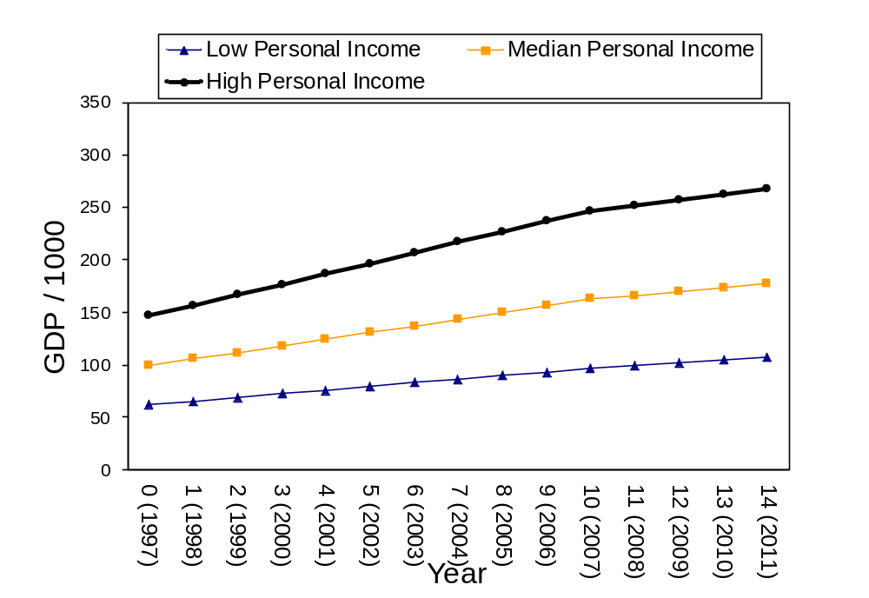

Notice that Personal Income has a fairly strongly relationship with the pre-2008 slope such that those States with higher Personal Income experienced a stronger increase in GDP relative to States with low Personal Income. Second, notice that although the transition effect was significant (and negative), the discontinuity is negligible and actually appears associated with a slight increase in GDP. As previously noted, the transition parameter is negative and significant only because the TIME slope would suggest additional growth that did not take place, so there is no real “drop” in performance in absolute terms in this example. Finally, notice that the recovery slope is less steep than the slope prior to 2008, but this effect is also dependent upon the level of personal income within States.

On-Your-Own

Continue using the dataframe “sleep.univ” and examine the level-2 predictor of AGE
- Determine whether AGE is related to intercept differences in sleep
- Examine whether AGE is related to the variance in the slope parameters

Hints: The model you are running is basically a replication of Bliese et al. (2007). None of the interactive effects will be significant with a p-value of .05, two-tailed; however, one of the parameters will be significant on a one-tailed test. The values parameter estimates and standard errors will slightly differ from the Bliese et al (2007) paper for reasons not entirely clear to me (though the substantive conclusions are basically the same).

